**CIRCUIT DIAGRAM**

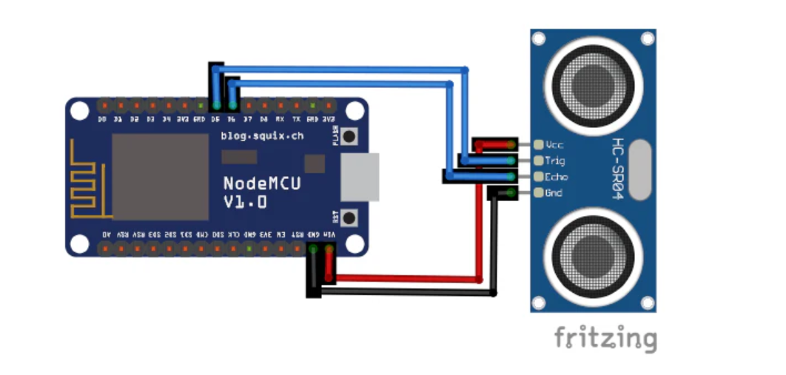

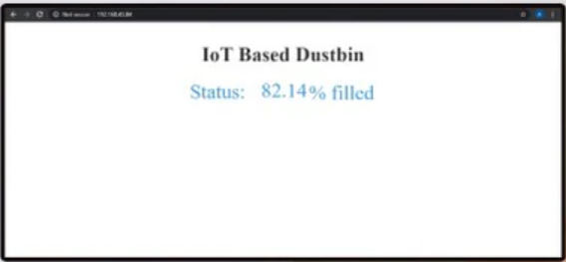

**Project Used Hardware**

* NodeMCU ESP8266 Controllers,
* Ultrasonic Sensor ,
* 12V Adapter ( PC)

**Project Used Software**

* Arduino IDE,

**SOURCE CODE**

#include <ESP8266WiFi.h>

const int trigPin = D5;

const int echoPin = D6;

long duration;

int distance;

float level;

const char* ssid = "Wi-Fi Name";

const char* password = "Password";

WiFiServer server(80);

void setup() {

pinMode(trigPin, OUTPUT);

pinMode(echoPin, INPUT);

Serial.begin(9600);

Serial.print("Connecting to WiFi Network: ");

Serial.println(ssid);

WiFi.begin(ssid, password);

while (WiFi.status() != WL_CONNECTED) {

delay(500);

Serial.print(".");

}

Serial.println("\nSuccessfully connected to WiFi.");

Serial.println("IP address: ");

Serial.println(WiFi.localIP());

server.begin();

Serial.println("Server started.");

}

void loop() {

digitalWrite(trigPin, LOW);

delayMicroseconds(2);

digitalWrite(trigPin, HIGH);

delayMicroseconds(10);

digitalWrite(trigPin, LOW);

duration = pulseIn(echoPin, HIGH);

distance = duration * 0.0340 / 2;

level = ((28 - distance) / 28.0) * 100;

Serial.print("Distance: ");

Serial.println(distance);

Serial.print("Fill Level: ");

Serial.println(level);

delay(1000);

WiFiClient client = server.available();

if (client) {

Serial.println("Web Client connected.");

String request = client.readStringUntil('\r');

client.println("HTTP/1.1 200 OK");

client.println("Content-Type: text/html");

client.println("Connection: close");

client.println("Refresh: 10");

client.println();

client.println("<!DOCTYPE HTML>");

client.println("<html>");

client.println("<head><title>IoT-Based Dustbin</title></head>");

client.println("<style>html { font-family: Cairo; text-align: center; color: #333333; background-color: #f3ffee;}</style>");

client.println("<h1>IoT-Based Dustbin</h1>");

client.println("<p>Fill Level: ");

client.print(level);

client.println("%</p>");

client.println("</html>");

delay(1);

}

}